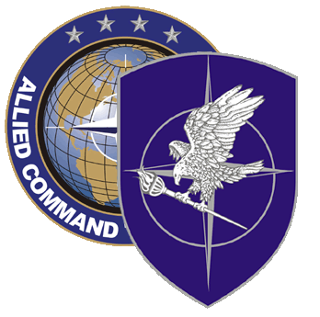
NATO SCHOOL: Global Leader in Multinational Military Education and Individual Training

M4-92 Movement and logistics Operational Planning Course (MLOPC)
The aim of this course is to make Logistic and Movement Staff Officers thoroughly understand the logistics planning at the operational level, as a sub-set of the OPP. The course fully integrates movement and logistic to generate an overall understanding of all logistical planning aspects and to ensure interaction between Logistics and Movement & Transportation (movement) specialists. Students will receive familiarization lectures on current logistic doctrines, policies and concepts to support this integrated approach.

Course Length: 2 weeks

Offerings per year: 3

Class Size: Max 66 / Min 24

Security Clearance: NATO UNCLASSIFIED

Characterization of Students/ Prerequisites:

- Academic: National and/or International Officers’ education or civilian equivalent in Logistics and/or movement. Having attended the NATO Logistics course prior is preferable.

- Language proficiency: Language proficiency: English IAW STANAG 6001 3232

- Computer skills: Student must be familiar with MS Word and PowerPoint.

- Designated reading material must be completed before start of course. Approved students will be informed by email of these requirements.

Course Objectives:

At course completion, the student should be able to:

- From a logistic and movement perspective, understand and apply the NATO Operations Planning Process (OPP) in accordance with the ACO Comprehensive Operations Planning Directive (COPD).

- Understand the considerations and limitations inherent to logistics and movement planning and apply NATO’s logistics and movement doctrines, concepts and procedures for planning and supporting NATO-led operations

- Describe the unique logistics and movement responsibilities of Air, Land, Maritime and SOF Component Commanders, and discuss doctrinal structures established to enable them to accomplish their logistical and movement-related responsibilities

